

**September to December**

**2023**



**Tue. 19th Sep.**

**Archibald Prize OR Rose Garden.**

Admire the Archies or the Rose Garden at the same Mornington address. Choice is yours.

(self book Archies, $15. 10.45am session.)

**Thu. 28th Sep.**

Mystery Tour

Stroll around a surprising suburban mall with plenty of morning tea options. Then lunch with a water view.

**Fri. 8th Sep.**

**Beasley’s Nursery and Teahouse.**

Enjoy wandering this East Doncaster nursery with a break or two in the Tea House.

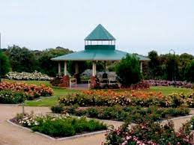

**Noticeboard:**

This round of Outings presents a choice of activities for a couple of the days…

Please note the revised fee for the Outings.

* **Social Sorties in green. (all abilities)**
* **Activeons** **in red. (active and able)**
* **(SD)** Short Day, 3-5 hours.
* **(LD)** Long Day, 6-7 hours.

**Remember to say hi and include those around you throughout the day.**

**Monday 14th August 2023 2023**

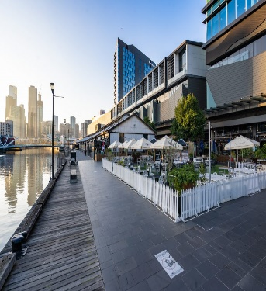

**Choices**

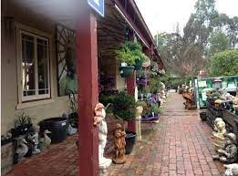

**Thu. 16th Nov.**

**South Morang to Warrandyte.**

A northern suburban café for morning tea with a lake view. Then to Bridges Nursery in Warrandyte for lunch.

* The cost of the bus is $10.00 per person. This will be billed to you after your travel.
* If you are unable to attend an outing, we require a **minimum of 24 hours’ notice**, otherwise you will be charged for the trip.
* Note, menu prices can vary and venues may change without notice.

**Please call with your wish list on the date below OR email anytime with your name/s, suburb, phone number and all wish list dates to: communitytransport@knox.vic.gov.au**

**Mon. 11th Dec.**

**DFO South Wharf OR**

**stroll Southbank**

Shop, watch the passing people parade or be a participant. The choice is yours.

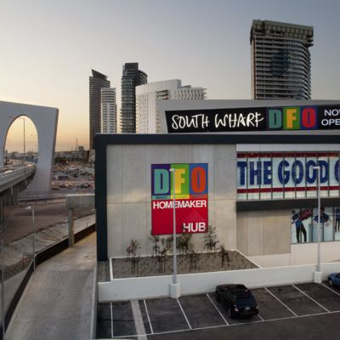

**Fri. 13th October**

**Walk - Mordialloc Pier to Parkdale Beach Café**

An estimated 2.2klm walk alongside Pt. Phillip Bay. Then dine at the Parkdale Beach Café.

**Choices**







