Community Transport Outings Program
Ferntree Gully | May – August 2024
The community transport service provides bus services for Knox residents who are over 65 years and/or need support with transport. Our day outings, provide the opportunity to visit places of interest across Victoria.
Community Transport Outings Program cost: Participation in the Community Transport Outings incurs a cost of $10.00* per person, to be invoiced post-travel. Should you be unable to join an outing, a minimum notice of 24 hours is necessary; otherwise, a trip charge will apply.
*Please note that starting July 2024, the cost will increase. Additionally, any entry fees at certain locations during outings will be your responsibility.
Morning tea/Lunch - Morning tea may be offered at some venues, subject to availability. We facilitate lunch* reservations at various establishments. It's important to be aware that if you choose to bring your own lunch, certain booked venues may not permit outside food within their premises.
*Lunch venues listed below are subject to change.
Pick up: From 9:00am onwards:
Stop 1 | Hutton Avenue Ferntree Gully
Stop 2 | Uniting Church 6 The Avenue Ferntree Gully
Stop 3 | Mountain Gate Shopping Centre (on public toilet side)
Bookings - Please call 9298 8518 (between 9:00am-4:30pm Mon to Fri) on 09th April with your wish list of outings OR email anytime with your name/s, suburb, phone number and all wish list dates to: communitytransport@knox.vic.gov.au. A member of the community transport team will get back to you with confirmation of your outings within two weeks of receipt of your wish list.
Timings - Please be advised that the timings provided in this itinerary are approximate and are subject to change. Various unforeseen factors, such as road works, traffic conditions, or other unexpected circumstances, may impact the scheduled times.
Extreme weather impact: Extreme weather conditions such as torrential rains, hot weather reaching or exceeding 38 degrees, may result in the outing program being cancelled (you will not be charged) for everyone’s safety. The Council may not be able to provide an alternative outing.
Walking levels- Please be aware that the level of walking involved in each outing may vary. Participants are responsible for assessing their own fitness levels and choosing outings that align with their abilities. While we make every effort to accurately describe the walking requirements, individual experiences may vary.
- Low Impact- Minimal walking required
- Moderate Walking- A moderate amount of walking involved
Thursday 02 May | Mystery Tour | 9:00am- 3:00pm | Moderate Walking
Immerse yourself in the lively atmosphere of this historic place, where bustling stalls offer an array of fresh produce, gourmet delicacies, artisanal crafts, and more. After exploring this mystery tour’s diverse offerings, treat your taste buds to a delightful lunch at one of the many eateries scattered throughout the place.
Wednesday 08 May | Showbiz cinemas and Lunch |9:00am- 2:30pm | Low Impact
Immerse yourself in an unforgettable cinematic experience at ShowBiz Cinemas in Mount Waverley. Indulge in the perfect blend of entertainment and dining with our exclusive package that not only promises a captivating movie screening but also includes a delectable lunch. Senior movie plus lunch ticket cost- $20.
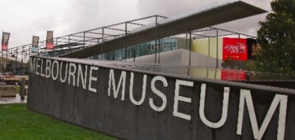
Friday 31 May | Melbourne Museum |9:00am- 3:00pm | Low Impact
Begin your journey at the Melbourne Museum, an iconic cultural institution that unveils the rich tapestry of Australia's natural and cultural history. After a morning of discovery, venture to South Bank food court for a delectable lunch experience.
Melbourne Museum entry ticket Senior price $10.
Tuesday 23 July | Morning Melodies |9:00am- 2:30pm | Low Impact
Indulge in a harmonious morning at Caldermeade farm, filled with enchanting music and exquisite flavours with Morning Melodies and a delectable two-course lunch.
Free entry for Morning Melodies. Two course lunch $21.95.

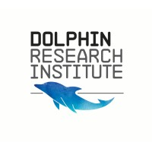
Wednesday 14 August | Dolphin Research Institute |9:00am- 2:30pm | Low Impact
Immerse yourself in an educational journey, exploring the fascinating world of dolphin behaviour and conservation efforts led by passionate experts. After an enriching morning at the Dolphin Research Centre, continue your maritime-themed adventure with a delightful lunch at Deoro by the Bay.
Dolphin Research Institute entry ticket $14.

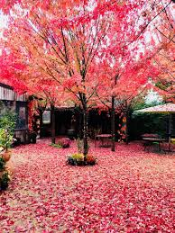
Wednesday 21 August | Alowyn Gardens |9:00am- 2:30pm | Moderate Walking
Whether you're a gardening enthusiast or simply seeking a peaceful escape,
the combination of Alowyn Gardens and lunch at Bridges Nursery and Cafe
promises a delightful day of beauty, relaxation, and culinary
delight in the picturesque Yarra Valley.
Entry Alowyn Garden Concession Ticket $12.50

