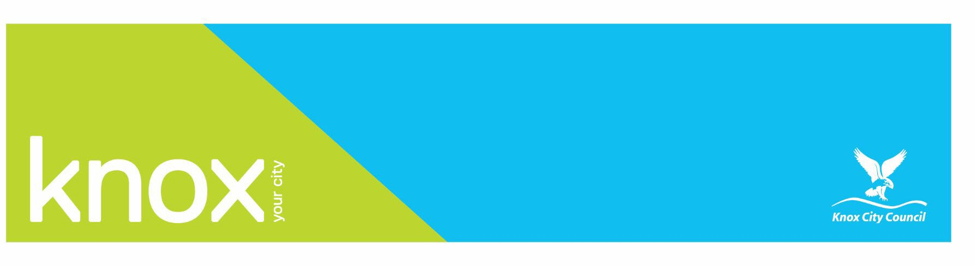
Apply for, Change, or Cancel Business Bins 2024-2025

Property address where waste service is required
Assessment Number (this can be found on the annual rates notice)
Unit/House Number | Street
Suburb | Postcode
Business Name: | Contact Person’s Name:
Business Phone: | Mobile:
Property owner or managing agent contact details
Are you the:

Surname | Given Name(s)
Phone Number | Email
Managing Agent Company Name and Suburb
Please complete this section advising us on the bins currently at the property. This information can
be found on the annual rates notice.
Option | Current Bin Combination | Number of bins
 | No bins at property
 | Number of 240 Litre Weekly collected Garbage bins (Brown Bin)
 | Number of 240 Litre Daily collected Garbage bins (Red bin)
 | Number of 240 Litre Weekly collected Recycle bins (Blue Bin)
To order an additional bin or change garbage collection frequency. Please tick the relevant option: if required
Option | Additional bin or change garbage collection frequency | Annual Fee
 | Change from a Weekly collected garbage bin to a Daily collected garbage bin | $2,457.55
 | Change from a Daily collected garbage bin to a Weekly collected garbage bin | $669.15
 | Additional 240 Litre weekly collected garbage bin (Brown Bin) Limit of 2 per property | $465.25
 | Additional 240 Litre Daily collected garbage bin (Red Bin) Limit of 2 per property | $2,253.65
 | New 240 Litre Weekly collected Recycle bin | $203.90
 | A Second x 240 Litre Weekly collected Recycle Bin Limit of 2 per property | $203.90

*Where the garbage bin frequency is to be changed, the Council will contact you to arrange for a bin to be left empty on the nature strip. Please advise Council if your bin collection area is not directly in front of your property.
To order bins for a Business that has not had a Council bin service before, please tick the relevant option for your new bin combination: if required
Date Business will be occupied*
Option | Bin option for new property | Annual Fee
 | 240 Litre Brown Garbage and Blue Recycle bin Collected Weekly | $669.15
 | 240 Litre Red Garbage Collected Daily on weekdays and Blue Recycle bin Collected Weekly | $2,457.55
 | 240 Litre Brown Garbage bin collected Weekly (no recycle bin) | $465.25
 | 240 Litre Red Garbage Collected Daily on weekdays (no recycle bin) | $2,253.65
 | Additional Brown Garbage bin collected Weekly | $465.25
 | Additional Red Garbage bin collected Daily on weekdays | $2,253.65
 | Additional Blue Recycle bin collected Weekly | $203.90
To cancel a bin service, please tick the relevant option of what bin(s) you would like to cancel:

Option | Cancel a Bin Service | Annual Fee
 | All bins at the property (Service no longer required)
 | Additional x Brown 240 Litre Garbage bin | $465.25
 | Additional x Red 240 Litre Garbage bin | $2,253.65
 | Additional x Blue 240 Litre Recycle Bin | $203.90

Further Information
General information

- Adjustments to the waste service being provided to a property are subject to pro-rata charges. All waste charges will be added to the Rates Notice for the property.
- Maximum of 2 x 240 Litre Garbage and 2 x 240 Litre Recycle Bins per property
- Bins remain the property of Knox City Council and must not be removed from the property.
- The council must be notified of any damaged or missing bins.
Pick up schedule
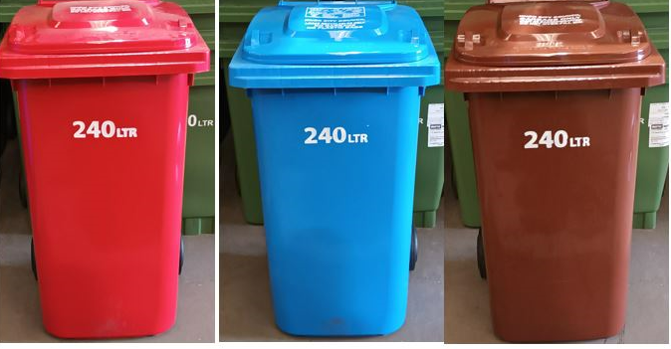
- Red Garbage bins are cleared Daily on weekdays.
- Brown Garbage Bins are cleared weekly.
- Blue Recycle Bins are cleared weekly.

Privacy statement
The personal information provided in this statement will be used for updating Council records and for the purpose of the service change/s requested. Where Council discloses your personal information to its contractors for these purposes, the contractor will be obliged to use that personal information in accordance with the terms of this privacy statement.
Please return completed form to Knox City Council
• Email - knoxcc@knox.vic.gov.au
• Postal address - 511 Burwood Highway Wantirna South VIC 3152

