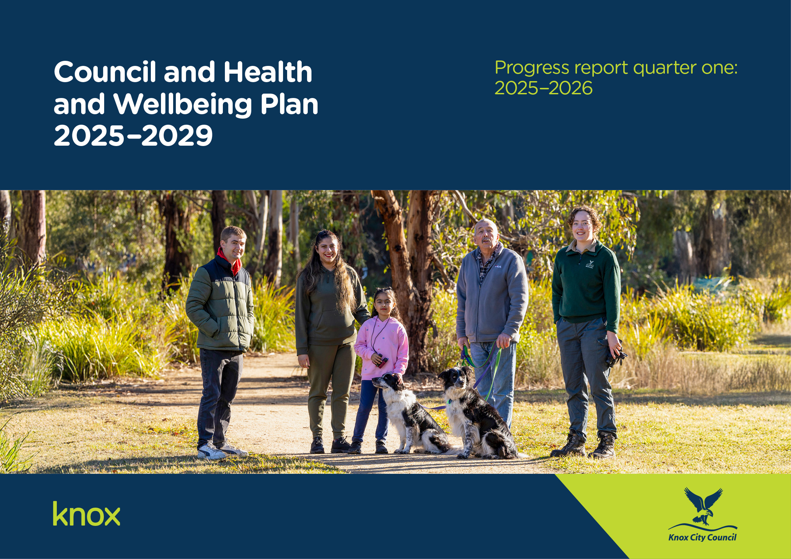
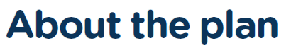

The Council and Health and Wellbeing Plan 2025-2029 was adopted on 23 June 2025 and is our promise to the Knox community. It sets out what we will do to respond to changing needs and has been shaped by our aspirations, needs, values and priorities. It informs long term financial planning with annual actions and performance measure targets represented in each Annual Budget.

To develop the Council and Health and Wellbeing Plan 2025-2029 we engaged over 1,100 community members to make sure the plan reflects the vision, values and aspirations of the people of Knox.

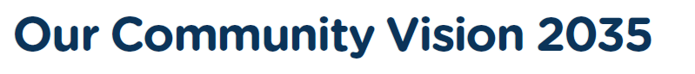
Progress Report: Q1, 2025/2026
Progress Report: Q1, 2025/2026
Our Community Vision describes our collective long-term hopes and aspirations for Knox. It helps us to plan for the needs of our community now and into the future.

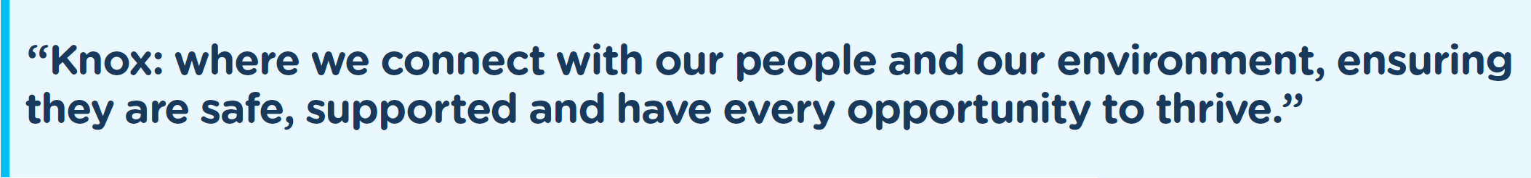

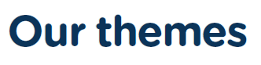
We have 6 key themes to focus on that help achieve our Community Vision. These themes reflect the priorities and aspirations of our community.

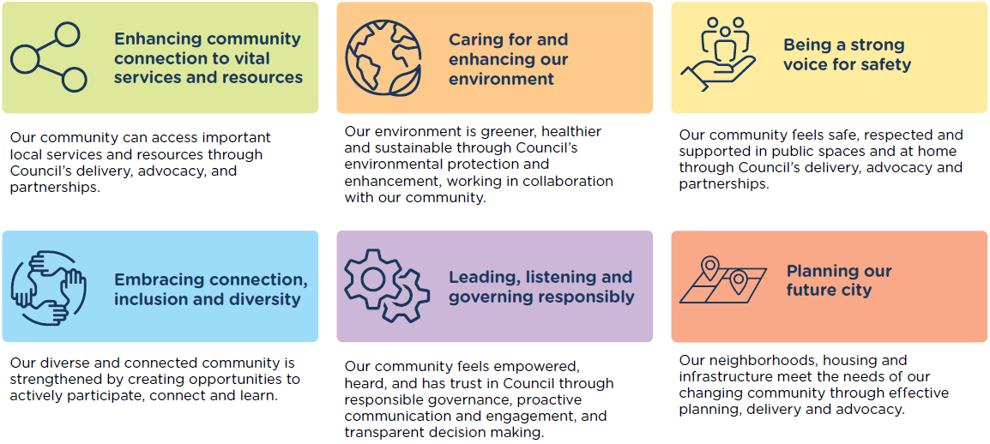

We understand that the health and wellbeing of our community is essential for our collective prosperity and quality of life. By measuring and addressing wellbeing, we can identify areas of need, track progress, and implement targeted interventions to create a healthier, more resilient community.

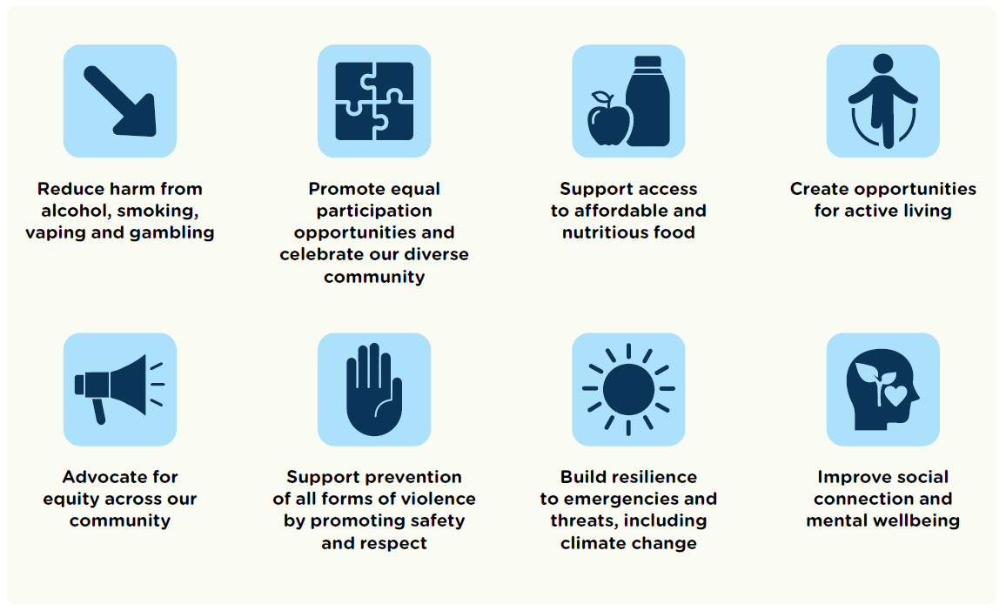
How to read this report
Annual actions
This report details the progress of the Council and Health and Wellbeing Plan 2025-2029 actions that are funded in the current financial year. These are the major initiatives that will be delivered during this financial year.

Progress status is reported based on the following colour coding:

Complete | On schedule | Behind schedule
 | ■ | ■

Performance measures
The quarter 2 and quarter 4 report will include the Council and Health and Wellbeing Plan 2025-2029 performance measures which demonstrate progress towards achieving each Strategic Objective. The performance measures include an annual target result, represented in the Annual Budget that will be reported against.

Progress Report Q1, 2025-2026
Annual actions summary
There are 45 actions to be delivered in 2025-2026. As of the latest reporting period, the overall implementation of these actions is progressing well with four actions completed and 41 on schedule.
Theme | Actions
Theme | Complete | On schedule | Behind schedule | Grand Total
Enhancing community connection to vital services and resources | 0 | 7 | 0 | 7
Embracing connection, inclusion and diversity | 1 | 9 | 0 | 10
Caring for and enhancing our environment | 0 | 7 | 0 | 7
Leading, listening and governing responsibly | 1 | 7 | 0 | 8
Being a strong voice for safety | 1 | 5 | 0 | 6
Planning our future city | 1 | 6 | 0 | 7
Total | 4 | 41 | 0 | 45
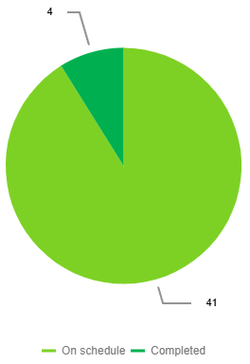
Enhancing community connection to vital services and resources
2025-2026 action | Progress | Comments | Status
Finalise and commence implementation of a Cemetery Landscape Masterplan to guide development of new ashes interment areas that meet community needs while complementing the existing amenity of the cemetery. | 25% | The second round of engagement for the draft Cemetery Masterplan has been completed. Community feedback from the engagement has been collated and provided to the landscape architect to inform the final draft of the Masterplan. The draft Masterplan is due to be presented to Council for adoption in December 2025. | On schedule | ■
Implement Economic Development's 2025-26 events program to strengthen capacity building for local businesses. | 25% | The 2025–26 Economic Development Events Program has launched with a strong mix of initiatives supporting business growth and engagement. Highlights include workshops on business structuring and succession planning, a manufacturing networking event promoting Australian-made industries, and a Business National Tree Day, which drew over 150 participants for tree planting and networking. A mental health focused session provided a supportive space for sharing workplace wellbeing strategies, while the Youth Expo delivered in partnership with Outer Eastern Local Learning & Employment Network (OELLEN), Yarra Ranges Council, and Maroondah City Council, connected young people with local career and training pathways. | On schedule | ■
Promote Your Library activities, programs and events that focus on lifelong learning, increase social connection and improve access to technology. | 30% | Council has collaborated with Your Library for the development of a 'Boronia, The Basin and Surrounds Community Directory', which was launched at Boronia library on 13 October 2025.  Collaborative efforts are also underway with Your Library on initiatives such as the Libraries after Dark program, the upcoming 2026 Move Your Way program and the VicHealth 'Secret World of Food' pop-up display that engages children and families in learn about the food system. | On schedule | ■
Improve our shared path network through new and renewed upgrades including the Liverpool Road shared path. | 25% | The newly adopted Knox Cycling Action Plan is being used to inform priorities in the shared path program from 2025-26 onwards. Construction works is 80% complete on the Green Spine off-road shared path in Chandler Road, Boronia. Planning permits and land agreements are being developed for the shared path in Liverpool Road between Mountain Highway and the municipal boundary. Design is ongoing for a shared path in Brennock Park Drive, Ferntree Gully. Design of the Railway Trail between Upper Ferntree Gully Station and Mount Dandenong Tourist Road is scheduled for 2026. Scoping of the Railway Trail between Underwood Road and Alpine Street has commenced with community engagement planned before the end of December 2025. Investigation is underway on possible future shared path projects in Railway Parade, Upper Ferntree Gully, between Burwood Highway and Quarry Road, and the Stud Road service road between George Street and The Close in Scoresby. | On schedule | ■
Advocate for enhanced bus service frequency and coverage across the Knox network and for release of the business case for transport options in the Caulfield-Rowville corridor. | 25% | A strategic and operational meeting to discuss key pipeline, traffic engineering and road safety matters was held in August 2025 between Council officers and Department of Transport and Planning (DTP) personnel. Council officers and Councillor Lockwood continued to attend the Eastern Transport Coalition (ETC) through which Knox continues to work with neighbouring Councils to support a coordinated approach to transport advocacy. ETC have submitted a budget bid document on behalf of member Councils. Key initiatives referenced in the document included redesign of the bus servicing arrangement between the tram terminus at Vermont South and bus routes along Mountain Highway to Baywater and undertaking a feasibility study to support the provision of a bus service connecting Bayswater to Stud Park via Henderson Road. Council also continues to pursue advocacy through the ETC by identifying priority safe arterial road crossing routes to enhance access to frequent bus services. Regular meetings are happening between Council officers and the Level Crossing Removal Projects group to discuss the Boronia Station Precinct Upgrade project. Items discussed include design details, land matters, and project risks. Council Officers are preparing a letter for the Federal Government calling for release of the Trackless Tram business case. | On schedule | ■
Lead and deliver the Knox Food Relief Taskforce and actively participate and contribute to the Knox Emergency Relief Network. | 25% | In July two member agencies from the Knox Food Relief taskforce were provided letters of support for support of the State Government 2025-26 Community Food Relief Local Grant Program. Council officers attended the August meeting of Knox Emergency Relief Network and facilitated the August Food Relief Taskforce meeting. Knox provided an opportunity for Taskforce members and their volunteers to attend Safe Food Handling training in September. Council officers also prepared a submission to the Federal Governments consultation on the national Strategy for Food Security. | On schedule | ■
Collaborate with Yarra Ranges Shire and Maroondah City Council to develop the Bayswater Business Precinct Spatial Plan. | 30% | The background report has been finalised and a business stakeholder workshop and cross-council internal visioning workshop was undertaken in September and October 2025. A draft Bayswater Business Precinct (BBP) Spatial Plan is expected to be provided to the three councils end of calendar year 2025, with internal briefings to be scheduled in early 2026. External consultation is expected to be conducted in mid-2026 across the three councils. | On schedule | ■
Embracing connection, inclusion and diversity
2025-2026 action | Progress | Comments | Status
Strengthen the ongoing partnership with sessional kindergarten providers operating from Council facilities through enhancement of processes and partnership meetings. | 40% | Partnership meetings are held bi-monthly with strong attendance from kindergarten providers. Work has been undertaken to discuss and review local priority of access criteria, kindergarten registration timings, kindergarten infrastructure and issues following the Victorian Governments Rapid Review into Child Safety. Draft Service Principles have been developed which will now go to the providers for feedback. | On schedule | ■
Consider the child perspective in service delivery, decision making and design through a Child Friendly Cities Education Campaign to build capability of our staff. | 35% | An Education and Communication plan has been drafted and developed in collaboration with the Communications Team to be finalised and approved end of 2025. This project has four stages, Stage 1: Awareness; a Knox wide campaign launch scheduled for early in 2026, followed by Stage 2: Learning and Capacity Building activities for all Knox staff. Stage 3 and 4: Embedding and Evaluation to occur by June 2026. | On schedule | ■
Deliver targeted programs for priority population groups, including intergenerational initiatives, for example an annual fishing program, to strengthen community connections. | 25% | Focusing on the digital divide that impacts seniors being able to connect and participate in activities, Council have partnered with Youngster.co to facilitate a ten-week pilot program between trained “youngsters” to provide tech support sessions for older members of our Knox community with their devices. These free sessions are being conducted in the Community Space at Westfield Knox. A focus of this program is around breaking down barriers of Ageism through intergenerational connections in a social space, whilst supporting our older local community with targeted technical support and providing tertiary students with social and life skills through customer service and face-to-face interaction. This initiative started in mid-September and will run until end of November.  The Armchair Travel program successfully piloted technology programming with iPads at September's Recreation for All Expo. Building on this success, additional programs utilising iPads and Virtual Reality (VR) headsets are now in development.  Preparations for Seniors Festival are progressing well, with the popular fishing program for vulnerable men returning this year. A new cooking program targeting older men is also scheduled for delivery in the coming quarter. | On schedule | ■
Undertake the Knox Aquatics Feasibility Study. | 25% | In Quarter one, a consultant was selected to Lead Stage 1 of the Aquatics Feasibility Study.  Site assessments have been completed, and the consultant has provided the draft Stage 1 Aquatics Feasibility Report to Council officers. | On schedule | ■
Deliver sporting club capacity-building sessions in partnership with key stakeholders. | 25% | During Quarter one various sporting club capacity building sessions were delivered. This included sessions on child safe standards, how to run a successful club, responsible service of alcohol and support to prevent vaping among young members of sports clubs. | On schedule | ■
Deliver the 2025-26 actions of the Alcohol Statement of Commitment implementation plan. | 25% | Council officers have met with the Alcohol and Drug Foundation to establish a Local Drug Action Team in Knox and have prepared a grant submission to support its formation.  The Knox Liquor Accord was held in July with 16 attendees consisting of Victoria Police, Department of Justice and Community Safety, Council and local liquor licensees. | On schedule | ■
Deliver volunteer training sessions and promote opportunities to strengthen social and community networks and reduce loneliness. | 25% | Three community training sessions held including; Running a successful Community Group/Sporting Club in August (33 people attended), Safe Food Handling in September (25 people attended) and Child Safe Training in September (22 people attended). Three Community Strengthening e-News bulletins have been circulated to 795 subscribers. | On schedule | ■
Partner with our diverse and multicultural community, key services and networks to support and celebrate our diversity, including the coordination of the Knox Community Safety, Health and Wellbeing and Multicultural Advisory Committees. | 25% | The Knox Multicultural Advisory Committee meeting was held in August with 16 attendees. Officers visited multicultural community groups regularly throughout the quarter to strengthen partnerships. Discussions commenced with the Events team to incorporate a multicultural presence at Knox Fest through stallholders and performances.  The Knox Community Safety, Health and Wellbeing Advisory Committee held its meeting in September to enable information sharing and seek opportunities for collaboration. | On schedule | ■
Review the Reconciliation Action Plan 2023-2025 and develop the next iteration of the plan. | 35% | A review of the actions delivered by Council from the Reconciliation Action Plan (RAP) 2023 - 2025 has been completed.  In September, Council noted the achievements delivered under the 2023-2025 RAP and endorsed the recommendation to develop the next iteration of the RAP, Innovate RAP 2026 - 2028. | On schedule | ■
Deliver the bi-annual Youth Summit to hear from the voices of young people on issues which are important to them. | 100% | Youth Services delivered the Youth Summit in August 2025 for young people aged 12-18 years. Every secondary school in Knox was invited to attend, with 6 schools represented on the day. 68 students registered, with 50 in attendance on the day. The delivery of the event was assisted by 16 Youth Advisory Committee members. The key topics of life skills and education, outdoor and recreation-based activities and how council communicates with young people were discussed on the day. Youth Services will use the information gained from the Youth Summit to inform service delivery for the next 18 months.  Two young people addressed Councillors in September to showcase the outcomes achieved from the Summit. The information and presentation from the young people was well received.  Youth Services is working with Council's Communications and Engagement team to develop a plan for engaging the 16-25 year cohort in further consultation opportunities. | Completed | 

Caring for and enhancing our environment
2025-2026 action | Progress | Comments | Status
Progressively replace fleet vehicles with zero/low emission vehicles. | 25% | Councils Fleet Replacement Program considers the changeover of the fleet assets to low emission alternatives at their replacement time and subject to benefit cost. Council has purchased a number of cordless tools that have replaced petrol-powered tools. Council has now 8 electric vehicles and 1 plug in hybrid in its fleet. | On schedule | ■
Finalise the first draft of the 10-year Open Space Strategy. | 20% | A Project Plan has been developed to deliver the strategy, with early stakeholder engagement undertaken in September/October 2025 with The Recreation and Leisure, Arts, Early Years and Multicultural advisory groups, with ongoing sessions planned with other advisory groups. Two separate briefing workshops for Councillors have been scheduled for late October/early November. Data gathering and analysis continues to be undertaken by the project team. | On schedule | ■
Deliver the year two funded actions of the Biodiversity and Resilience Strategy 2024-2034 Action Plan. | 20% | Council has implemented the updated version of the Knox Council Sites of Biological Significance. The revised document is now available on the Knox Council website.  An annual Citizen Science Program is conducted each year to encourage community participation in environmental monitoring and data collection. This quarter, activities included iNaturalist training and participation in the Greater Melbourne bioblitz.  Annual revegetation activities are carried by the Biodiversity team to enhance local habitats. This quarter, activities included supporting community planting events such as National Tree Day, Corporate National Tree Day and Wattle tree day, which engage the community in habitat restoration efforts.  The Urban Forest group recently met to share current projects and strategies related to tree protection, habitat corridor management, and urban canopy enhancement. The group will continue to meet regularly to share their knowledge, challenges and upcoming projects across departments.  Environmental Friends Groups and volunteers continue to receive support to network, connect, and build their capacity through mentoring and training opportunities. This includes initiatives such as Sites of Biological Significance and volunteer training sessions, aimed at strengthening community involvement in environmental stewardship. | On schedule | ■
Deliver the annual Sustainability Initiatives of Council's Capital Works Program to reach net zero emissions by 2030. | 25% | The sustainability initiatives in the Capital Works program are underway with projects including the installation of pool blankets to the 50m Pool at Knox Leisureworks, lighting upgrades to Knoxfield Tennis Club and efficiency upgrades to lighting and air conditioning at Knox Civic Centre. | On schedule | ■
Conduct the mid-term review of Council's Climate Response Plan 2021-2031. | 25% | The Climate Response Plan (CRP) mid-term review is underway with a number of workshops with responsible business units to understand the status of CRP actions and what if any actions are required to be amended as part of the review. | On schedule | ■
Advocate to Federal and State Governments to reconsider the kerbside glass only service reform, in favour of an expanded Container Deposit Scheme (CDS) to enhance glass recycling and reduce cost to the Knox community. | 50% | Officers continued advocacy to the Victorian Government on the implementation of kerbside reforms. Knox is an active member of a 34 Council group seeking action from the Minister for Environment to ensure fair and best practice outcomes for the Community from the waste and recycling service standards which currently await final approval. | On schedule | ■
Participate in the South East Metropolitan Advanced Waste Processes Project Oversight Group, to oversee facility construction and report back to Council. | 20% | A representative from Knox Council has been appointed to the Project Oversite Group with an initial meeting to be scheduled in October 2025. | On schedule | ■

Leading, listening and governing responsibly
2025-2026 action | Progress | Comments | Status
Optimise Council's key communication channels to ensure our customers have easy access to relevant and timely information. | 25% | Sixteen external channels have been identified and project documentation established. An initial strengths, weaknesses, opportunities and threats (SWOT) analysis of eight priority channels has been completed. Phase 1 assessment and initial documentation, which includes ownership and governance; costs; specifications and requirements; audience and internal understanding of channel scope has been completed for six external channels. | On schedule | ■
Finalise the platform tender process for Core Business Systems to integrate technology systems into a single source of truth, optimising efficiency, cybersecurity and productivity. | 85% | The tender process has completed the thorough product evaluation stage and is scheduled to proceed to Council for discussion and endorsement next quarter. | On schedule | ■
Develop and endorse Council's Annual Budget 2026-27. | 15% | Community engagement to inform the development of the 2026-2027 Annual Budget was completed in August with a report noted by Council at the Council Meeting on 29 September 2025. Strategic workshops have been undertaken with councillors to understand their priorities for the 2026-2027 year. | On schedule | ■
Actively pursue and participate in collaborative procurement opportunities to maximise contract outcomes. | 20% | Discussions at the Eastern Regional Network are ongoing and procurement events are being considered for collaboration at preparations stages. Several collaborations have been successful and will continue to be explored as a group for aggregation and efficiencies. This is not limited to tendering events but also includes processes and templates. | On schedule | ■
Deliver the year one actions of Council's Organisation Strategy 2025-29. | 25% | Our Organisation Strategy focuses on five key themes. It encourages our people to be customer centric, people focused, financially sustainable, change ready and outcomes driven. Delivery of the ten actions within the Organisation Strategy is underway with the following highlights from this quarter:  - The new annual planning cycle has been widely communicated across Council with staff having a clear understanding of what is required from them each quarter to deliver on the community's priorities.  - The new work and development plan process has been implemented with leader and staff conversations currently underway.  - Data packs have been created for each service across the organisation to inform annual planning. These include information pertaining to customer complaints, voice of the customer, customer telephone call, community satisfaction and community engagement. | On schedule | ■
Complete a community engagement program to inform Council's Annual Budget 2026-27. | 100% | Community engagement for the Annual Budget and Action Plan was undertaken between 28 July and 24 August 2025 with 594 responses from community members and eight formal submissions. The engagement activities were focused on understanding how we can best meet community needs under each theme of the Council and Health and Wellbeing Plan, community ideas for actions or projects in a specific location in Knox and the services our community think deliver most value. Engagement activities included an online survey, five pop-up events across the municipality and targeted events at the hubs and with the multi-advisory committee. The community engagement report was presented to Council at the Council Meeting on 29 September 2025 with formal submissions being heard on 1 October 2025 by Councillors. | Completed | 
Develop and launch a Continuous Improvement Framework and Year 1 program of initiatives to improve customer experience, staff experience, and operational efficiency. | 10% | Work is progressing in the development of the Continuous Improvement Framework, following investigation into historical approaches and assessment of the organisational readiness and capability in this space. Further consultation with the organisation will occur in quarter 2 to ensure a fit-for-Knox outcome. | On schedule | ■
Develop and endorse Council's Asset Plan 2025-2035. | 90% | The draft Asset Plan 2026-2035 is scheduled to go before Council for endorsement on the 27 October 2025, following community consultation. | On schedule | ■

Being a strong voice for safety
2025-2026 action | Progress | Comments | Status
Complete the Domestic Animal Management Plan 2025-2029. | 75% | The draft Domestic Animal Management Plan (DAMP) 2025-2029 is currently out for public consultation. Feedback received will be reviewed, and the final plan is scheduled to be presented to Council for adoption in early 2026. | On schedule | ■
Partner with key stakeholders to deliver community safety programs and initiatives that improve perceptions of safety and neighbourhood connection. | 25% | Officers attended a number of community safety events and meetings that assists in taking a collaborative and partnership approach to improving perceptions of safety, such as participating in events for community safety month, attendance at the Eastern Region Group Community Safety Roundtable, attendance at Empowering Connected Communities meetings, with a focus on starting to plan for Neighbour Day 2026, trader visits with Victoria Police to Ferntree Gully Village and Mountain Gate Shopping centre to discuss safety issues, partnership created with Victoria Police to establish a Local Safety Committee, attendance at Seniors Month Launch to promote community safety and handed out over 30 Safe Plate screws to local community members. Planning is underway for a Children's week event and collaboration with Westfield in their Community Safety Day at the end of October. | On schedule | ■
Participate in the Eastern Metropolitan Council's Emergency Management Partnership (EMCEMP) in order to deliver a collaborative approach to regional emergency preparation and preparedness. | 100% | Knox City Council has recently signed a new partnership agreement with the EMCEMP Councils, including ongoing funding for the next four years to enable a collaborative approach to regional emergency preparation and preparedness. Under this new partnership, officers will continue to participate in the collaboration. | Completed | 
Develop a first draft of a Public Lighting Policy for Knox to extend usable hours and improve perceptions of safety in public spaces. | 15% | A review of Public Lighting Policies of other municipalities is underway in preparation for the development of the project working group. | On schedule | ■
Deliver year two of the Free From Violence project. | 25% | Active Bystander training was delivered to 60 staff in August. 86% of participants said that after the training, they had an improved understanding of structural oppression (e.g. sexism, racism), and how this disproportionately impacts some groups. There was also a 20% increase in participants' confidence in taking bystander action following the training.  Gender Equity kits have been delivered to Knox tenant kindergartens, a kit full of resources to assist educators in embedding gender equity and equality across their centres. | On schedule | ■
Celebrate the achievements of women and progress towards gender equality through the delivery of International Women's Day event and 16 days of Activism Against Gender-Based Violence in partnership with our community. | 25% | Planning for 16 Days of Activism in November and December is well underway. The activities include; a community webinar on 26 November, delivered in partnership with Maroondah, Monash and Yarra Ranges Councils aimed at parents and carers of young people aged 8-14. The webinar will focus on supporting young people to build healthy and respectful relationships. Council is also planning for the delivery of Active Bystander training to winter tenant sporting clubs on 10 December. Council has been working with Libraries to deliver specific story-times for children, as well as providing booklist recommendations and setting up book displays that tie into the themes of Respect. | On schedule | ■

Planning our future city
2025-2026 action | Progress | Comments | Status
New or upgraded Council facilities are designed to be Disability Discrimination Act compliant. | 25% | All new builds requiring a building permit are Disability Discrimination Act (DDA) compliant, as required under the Building Regulations, ensuring inclusive and accessible design across community infrastructure. The detailed designs for the Carrington Park Pavilion upgrade and Park Ridge Pavilion refurbishment were completed this quarter, incorporating Disability Discrimination Act (DDA) compliance. | On schedule | ■
Assess building condition audit data and create renewal programs to align with building hierarchy and the long-term financial plan. | 100% | A prioritised renewal program has been prepared utilising the 2024 building condition audit data. This renewal program aligns with building hierarchy and the long-term financial plan. | Completed | 
Review the Public Toilet Policy and develop the next iteration of the Policy and Implementation Plan. | 20% | A review of the existing Public Toilet Policy and Implementation Plan has commenced. | On schedule | ■
Commence preparation of the Knox Housing Strategy review following release of the new Plan for Victoria and State housing targets to ensure that Knox is well placed to respond to legislative change and market demands. | 5% | This project has been delayed in recent times due to extensive reform to the Victorian planning system by the State Government and local government elections in 2024. This has impacted Council's ability to finalise a project scope, brief the new Council and commence work with certainty. Councillors have since been briefed at a workshop held on 18 August 2025, and background analysis is underway.  Uncertainty remains from the State Government including the timing and substance of built form modelling across Melbourne to accommodate housing targets. This could impact on the strategy development phase and a final form of a housing strategy for Knox. | On schedule | ■
Prepare the Bayswater Renewal Strategy Planning Scheme Amendment for implementation into the Knox Planning Scheme. | 10% | The draft amendment has been prepared and has been lodged with the Minister for Planning for authorisation. Officers are awaiting authorisation from the Department of Transport and Planning (DTP) before a further report will be presented to Council to advise Council of the final documents that will be circulated during public exhibition for community and stakeholder feedback in 2026. | On schedule | ■
Advocate and provide support for eligible community members over 55 to access safe and affordable housing. | 25% | Demand for assistance accessing safe and affordable housing continues to be high. This quarter, 63 enquiries have been processed, supporting 48 individual clients. There are currently 69 people on the over-55 housing waitlist. Due to limited availability and slow turnover of units, Officers have proactively engaged with external community housing providers to advocate for long-term housing options, including the Community Housing Limited development in Wantirna.  The Short-Term Support team continues collaborating with the Department of Family Fairness and Housing (DFFH) regarding key housing estates in Knox. They are also working collaboratively to strengthen resident connections with the DFFH Ringwood Housing Office to improve access to community supports to reduce social isolation for residents. | On schedule | ■
Deliver the year three actions of the Social and Affordable Housing Strategy 2023-2027. | 25% | The Mid Term Review of the Social and Affordable Housing Strategy has been undertaken and will be presented to Council in November. Knox in collaboration with Eastern Affordable Housing Alliance (EAHA) successfully delivered a webinar for Homelessness Week in August 2025. The webinar covered alternative supports for people experiencing homelessness, such as a shower program, support for people with pets, and access to laundry services. 271 people have viewed the recording of the webinar. | On schedule | ■

