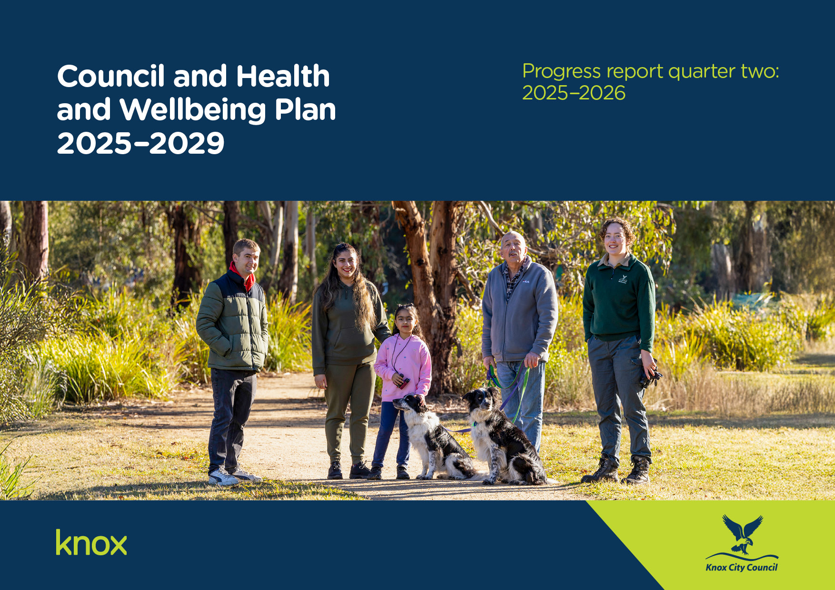
O=
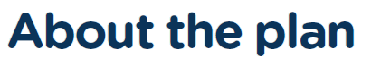

The Council and Health and Wellbeing Plan 2025-2029 was adopted on 23 June 2025 and is our promise to the Knox community. It sets out what we will do to respond to changing needs and has been shaped by our aspirations, needs, values and priorities. It informs long term financial planning with annual actions and performance measure targets represented in each Annual Budget.

To develop the Council and Health and Wellbeing Plan 2025-2029 we engaged over 1,100 community members to make sure the plan reflects the vision, values and aspirations of the people of Knox.

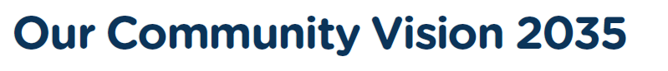
Progress Report: Q1, 2025/2026
Progress Report: Q1, 2025/2026
Our Community Vision describes our collective long-term hopes and aspirations for Knox. It helps us to plan for the needs of our community now and into the future.

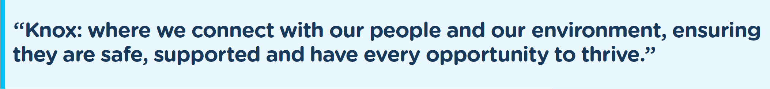


We have 6 key themes to focus on that help achieve our Community Vision. These themes reflect the priorities and aspirations of our community.

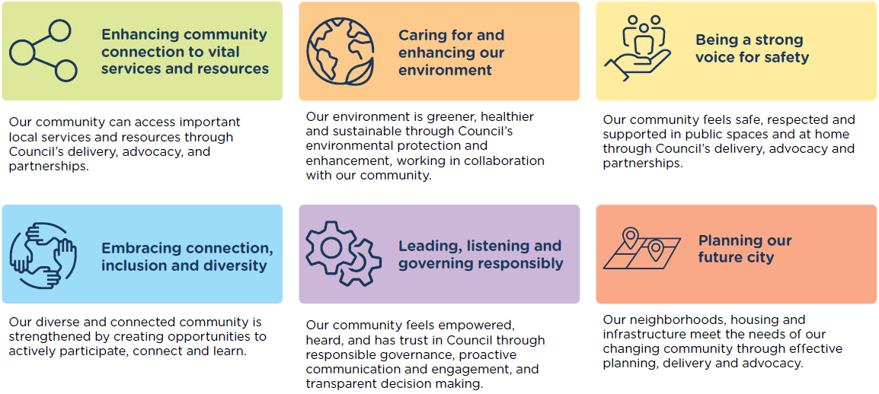

We understand that the health and wellbeing of our community is essential for our collective prosperity and quality of life. By measuring and addressing wellbeing, we can identify areas of need, track progress, and implement targeted interventions to create a healthier, more resilient community.

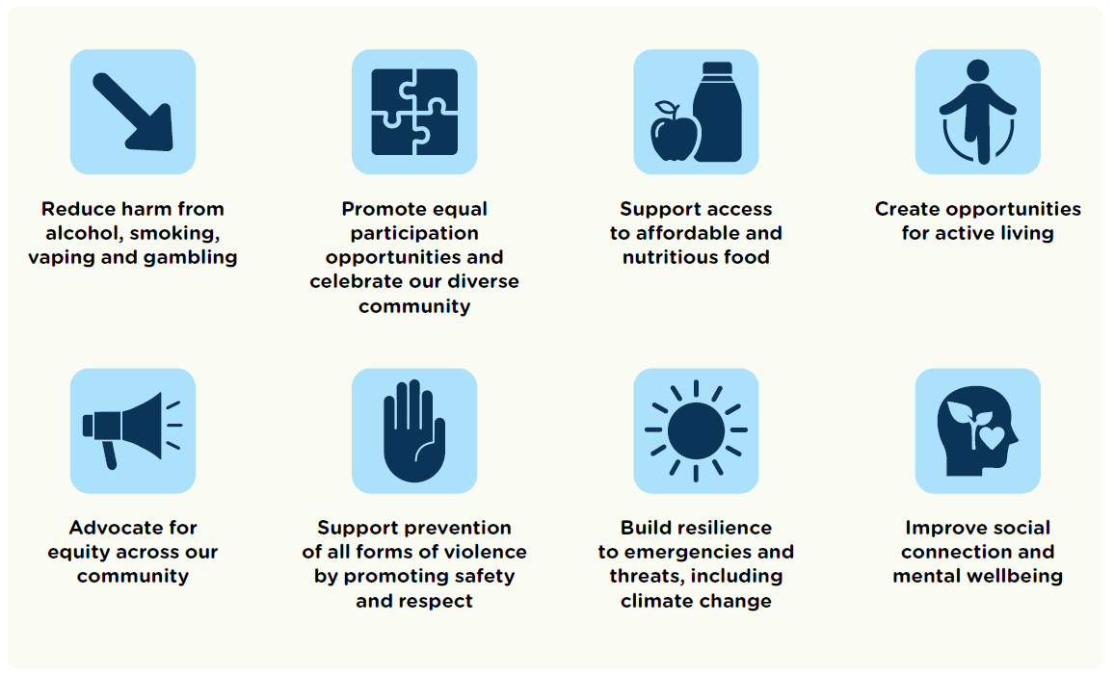

How to read this report

Actions

This report details the progress of the Council and Health and Wellbeing Plan 2025-2029 actions that are funded in the current financial year. These are the major initiatives that will be delivered during this financial year.

Progress status is reported based on the following colour coding:

Complete | On schedule | Behind schedule
 | ■ | ■

Performance measures

This report also includes the Council and Health and Wellbeing Plan 2025-2029 performance measures which demonstrate progress towards achieving each Strategic Objective. The data reflects year-to-date results and will be updated again in quarter 4. Each measure is tracked against its annual target as set out in the Annual Budget.

Progress Report Q2, 2025-2026

2025-26 actions summary

There are 45 actions to be delivered in 2025-2026. As of the latest reporting period, the overall implementation of these actions is progressing well with six actions completed and 39 on schedule.
Theme | Actions
Theme | Complete | On schedule | Behind schedule | Grand Total
Enhancing community connection to vital services and resources | 0 | 7 | 0 | 7
Embracing connection, inclusion and diversity | 1 | 9 | 0 | 10
Caring for and enhancing our environment | 0 | 7 | 0 | 7
Leading, listening and governing responsibly | 3 | 5 | 0 | 8
Being a strong voice for safety | 1 | 5 | 0 | 6
Planning our future city | 1 | 6 | 0 | 7
Total | 6 | 39 | 0 | 45
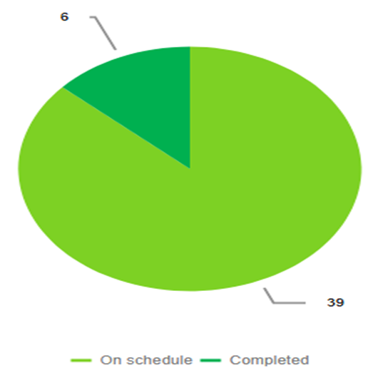

Theme 1: Enhancing community connection to vital services and resources

Actions

Action | Progress | Comments |  | Status
Finalise and commence implementation of a Cemetery Landscape Masterplan to guide development of new ashes interment areas that meet community needs while complementing the existing amenity of the cemetery. | 50% | Following a second round of community engagement, the Ferntree Gully Cemetery Masterplan was completed with consideration given to feedback received from the community. The Masterplan was presented to Council at the Council Meeting of 15 December 2025 and was adopted at this meeting. Implementation will now commence with a focus on high priority projects identified in the Masterplan. A progress report will be presented to Council in May 2026. |  | On schedule |  | ■
Implement Economic Development's 2025-26 events program to strengthen capacity building for local businesses. | 50% | The 2025-26 Economic Development Events Program continues to provide a strong mix of initiatives supporting business growth and engagement. Highlights include a Wellbeing in Business: Dream It, Do It, Sustain It workshop, a networking cybersecurity session at Australia's first tier IV data centre delivered in partnership with the Bayswater Business Precinct and a Young Entrepreneurs Networking Event. |  | On schedule |  | ■
Promote Your Library activities, programs and events that focus on lifelong learning, increase social connection and improve access to technology. | 50% | Officers attend regular meetings with Your Library to plan and review programming and events. This quarter, key programs included the 16 Days of Activism story times, which focused on challenging gender stereotypes and were delivered in Knox, Rowville and Millers. The Libraries After Dark initiative was also promoted at Boronia and Knox. Planning progressed for upcoming Move Your Way and Secret World of Food events, scheduled for delivery in quarter three. The opening of the Bayswater Library was widely promoted through social media, newsletters and other communication channels. |  | On schedule |  | ■
Improve our shared path network through new and renewed upgrades including the Liverpool Road shared path. | 50% | The Knox Cycling Action Plan is guiding shared path priorities for 2025-26. Construction of the Green Spine path in Chandler Road, Boronia is 95% complete. Planning and land agreements are progressing for the Liverpool Road path, with the aim of commencing works before the end of the financial year. Design work continues for Brennock Park Drive. Railway Trail design between Upper Ferntree Gully Station and Mount Dandenong Tourist Road is scheduled for 2026, with scoping for the Underwood Road and Alpine Street section completed following December 2025 engagement. Investigations are also underway for future shared path projects in Railway Parade, Burwood Highway to Quarry Road, and the Stud Road service road in Scoresby. |  | On schedule |  | ■
Advocate for enhanced bus service frequency and coverage across the Knox network and for release of the business case for transport options in the Caulfield-Rowville corridor. | 50% | Two strategic meetings and one operational meeting were held in quarter two between Council officers and Department of Transport and Planning (DTP) to discuss key pipeline, traffic engineering and road safety matters. Council officers and Councillor Lockwood continued to participate in the Eastern Transport Coalition (ETC), which is preparing a State election advocacy document featuring initiatives such as improved bus connections between Vermont South, Mountain Highway and Bayswater, and a feasibility study for a Bayswater to Stud Park bus link via Henderson Road. Through the ETC, Council is also identifying priority safe arterial road crossings to improve access to frequent bus services. Regular meetings are continuing with the Level Crossing Removal Project team on the Boronia Station Precinct Upgrade, covering design, land matters and project risks. Council officers are also preparing a letter to the Federal Government requesting release of the Trackless Tram business case. |  | On schedule |  | ■
Lead and deliver the Knox Food Relief Taskforce and actively participate and contribute to the Knox Emergency Relief Network. | 50% | Taskforce and Knox Emergency Relief Network (KERN) meetings were held in quarter two, with progress made on securing more support from local businesses, exploring food safety training for food relief agencies and scoping a food literacy project. Work also continued with Yarra Ranges, Maroondah and Eastern Health through the Outer East Food Relief Dialogue, supported by a student research project that gathered local and regional information from food relief agencies. The findings will be shared with the community in 2026 and will guide future Dialogue group activities. |  | On schedule |  | ■
Collaborate with Yarra Ranges Shire and Maroondah City Council to develop the Bayswater Business Precinct Spatial Plan. | 60% | The Draft Bayswater Business Precinct (BBP) Structure Plan was provided by Hansen before Christmas 2025. City Strategy has reviewed the document and will liaise with Maroondah City Council and Yarra Ranges Council to progress through the Executive Leadership Team before it moves to community consultation. |  | On schedule |  | ■

Performance measures

Performance Measure | Annual Target | Half Yearly Result | Comments
Kilometres of new active transport in Knox aligned with the Knox Cycling Action Plan and other active transport plans. | 2Kms | 0Kms | On target: The main shared path for partial delivery in 2025-26 is Liverpool Road between Mountain Highway and the municipal boundary. Design is complete, land agreements are being developed and planning permits for tree removal are being sought. Approximately 20% of the funding is available in 2025-26 for this project and the balance is earmarked for 2026-27. On-road bike lanes will be installed in Barmah Drive East in quarter four of 2025-26. Footpaths are planned for construction in Pleasant Road, Ferntree Gully and Llewellyn Drive, Wantirna South in quarter three 2025-26. Footpaths will be constructed in Park Ridge Reserve, Rowville and Gerald Street reserve in quarter four 2025-26.
Community satisfaction with bike and shared paths (both on road and off-road and including shared paths). | 79-80 | Data not yet available | This data will be collected in the annual Community Satisfaction Survey (CSS) in March 2026.
Community satisfaction with the maintenance and repair of sealed and local roads. | 68-70 | Data not yet available | This data will be collected in the annual Community Satisfaction Survey (CSS) in March 2026.
Number of visits to libraries in the Knox municipality. | 625,00 - 640,000 | 389,737 | On target
Community satisfaction with local library services. | 8.5-8.6 | Data not yet available | This data will be collected in the annual Community Satisfaction Survey (CSS) in March 2026.
Number of planning permits issued for commercial, office or retail use and development. | 130-150 | 48 | Behind target: 48 planning permits were issued for commercial, office or retail use and development from 1 July to 31 December 2025. We still anticipate reaching annual target depending on economic conditions.
Value of grants provided to emergency relief organisations. | $100,000 | $100,000 | On target: The Emergency Relief Grant was established in July 2025 with an annual allocation of $100,000. This grant stream was exhausted in November 2025 with all grant money going to Emergency Relief organisations with the City of Knox.
Self-reported health status of Knox residents. | 36%-38% | 37% | Ahead of target: This figure is obtained from the Victorian Population Health Survey which is undertaken every 4-6 years. The latest figures are from 2023 and state that the 'self-reported health status of Knox residents is excellent/very good 37.2%'. The next survey is expected to be undertaken in 2026 with data released in 2027.
Amount of gross regional product (GRP) ($) generated by businesses in Knox. | $9.4B-$9.7B | Data not yet available | The most recent Gross Regional Product (GRP) data available for the City of Knox is for 2023-2024. The City of Knox’s GRP was $12.10 billion in the year ending June 2024, an increase of 0.6 per cent from the previous year. Economic data providers such as the National Institute of Economic and Industry Research (NIER), Economy ID and Remplan rely on several external datasets that are released well after the end of the financial year. These include the State Accounts, which were released in late November and the Australian National Accounts Input-Output Tables, which will not be available until March this year. Additional datasets from the Australian Taxation Office (ATO) will not be provided to NIEIR until late 2025. Economy ID is expected to receive the first Local Government Area estimates for 2024-2025 GRP in April 2026.
Community satisfaction with Council services and facilities. | 7.7-7.9 | Data not yet available | This data will be collected in the annual Community Satisfaction Survey (CSS) in March 2026.

Theme 2: Embracing connection, inclusion and diversity

Actions

Action | Progress | Comments | Status
Strengthen the ongoing partnership with sessional kindergarten providers operating from Council facilities through enhancement of processes and partnership meetings. | 60% | Partnership meetings continued throughout 2025, with strong attendance from all Central Registration Participating kindergarten providers. In December we finalised our collaborative work in relation to foundational operational policy and procedures and guiding principles setting up the operational processes for the next 3 years. Further work will be undertaken in 2026 regarding Kindergarten Reform changes. | On schedule | ■
Consider the child perspective in service delivery, decision making and design through a Child Friendly Cities Education Campaign to build capability of our staff. | 50% | An Education and Communication plan has been drafted and developed in collaboration with the Communications Team to be finalised and approved end of 2025. This project has four stages,  - Stage 1 – A Knox-wide awareness campaign  - Stage 2 - Learning and capacity building activities for all Knox staff  - Stage 3 & 4: Embedding and evaluation  Stage 1 is scheduled for launch in February 2026. | On schedule | ■
Deliver targeted programs for priority population groups, including intergenerational initiatives, for example an annual fishing program, to strengthen community connections. | 50% | During quarter two, a total of 27 intergenerational programs were delivered, all aimed at building connections across different ages. Participants included residents from four aged care facilities, local community members, open spa children, primary and secondary school students and tertiary students. A key highlight was the completion of the Youngster.co tech support program, which was well received and supported older residents with technology. 63 older community members booked into these sessions during the quarter. As part of the Seniors Festival, a fishing program for vulnerable older men and a cooking program for older men were delivered, both receiving positive feedback and helping participants form new social connections. | On schedule | ■
Undertake the Knox Aquatics Feasibility Study. | 30% | Council Officers have reviewed the feasibility reports provided by Williams Ross Architects and are working with them to finalise the technical assessment component of the feasibility study. Officers will now commence a strategic review to assess the needs and provision of aquatics in the municipality. | On schedule | ■
Deliver sporting club capacity-building sessions in partnership with key stakeholders. | 50% | During quarter two, a number of sporting club capacity building sessions were delivered in partnership with key stakeholders. Sessions included Strategic Planning for Clubs, Building Club Culture for Success and a Women and Girls Forum in partnership with Yarra Ranges and Cricket Victoria. These workshops aimed to build club capacity and provide practical tools for sustainable club management. | On schedule | ■
Deliver the 2025-26 actions of the Alcohol Statement of Commitment implementation plan. | 40% | Initial consultation to establish the Knox Local Drug Action Team (LDAT) was undertaken with the Community Safety, Health and Wellbeing Advisory Committee in December. Council has subsequently signed the contract to act as the lead agency for LDAT, with the first Knox LDAT meeting scheduled for January 2026.  The Knox Liquor Accord meeting was held on 27 November, with 14 attendees representing Victoria Police, Liquor Control Victoria, EACH, Dalgarn Institute, and local liquor licenses. | On schedule | ■
Deliver volunteer training sessions and promote opportunities to strengthen social and community networks and reduce loneliness. | 50% | Two community training sessions were delivered this quarter: Managing Challenging Member and Volunteer-Related Situations in October, attended by 25 participants, and Building Aboriginal Cultural Competency in November, attended by 17 participants. Three Community Strengthening e-News bulletins were also distributed to 783 subscribers.  Two additional sessions - Cultural Awareness and 3Rs of Family Violence - were scheduled for October but were postponed to 2026 due to low registration numbers. | On schedule | ■
Partner with our diverse and multicultural community, key services and networks to support and celebrate our diversity, including the coordination of the Knox Community Safety, Health and Wellbeing and Multicultural Advisory Committees. | 50% | The Knox Community Safety, Health and Wellbeing Advisory Committee met in December and provided feedback on the Open Spaces Strategy and on upcoming alcohol harm -reduction initiatives, including work being delivered in partnership with the Alcohol and Drug Foundation (ADF) through the Local Drug Action Team (LDAT). The meeting also supported information sharing and identified opportunities for collaboration in 2026. | On schedule | ■
Review the Reconciliation Action Plan 2023-2025 and develop the next iteration of the plan. | 50% | Council endorsed report on 29 September to develop the Innovate Reconciliation Action Plan (RAP) 2026–2028.  Community Partnership and Inclusion are currently progressing the engagement and development of the next RAP, including meetings and engagements with community and key Council teams. General staff engagement sessions were offered at the end of 2025. | On schedule | ■
Deliver the bi-annual Youth Summit to hear from the voices of young people on issues which are important to them. | 100% | Youth Services delivered the Youth Summit in August 2025 for young people aged 12 to 18 years. Every secondary school in Knox was invited, with six schools represented on the day. 68 students registered and 50 attended. The event was supported by 16 Youth Advisory Committee members. Key topics discussed included life skills and education, outdoor and recreation activities and how Council communicates with young people. Youth Services will use the insights from the Summit to guide service delivery for the next 18 months.  In September, two young people presented the Summit outcomes to Councillors, and their contribution was well received.  Youth Services is also working with Council’s Communications and Engagement team to develop a plan to engage the 16-to-25-year age group in further consultation opportunities. | Complete | 

Performance measures

Performance Measure | Annual Target | Half Yearly Result | Comments
Participation of young people in Youth Services programs. | 7,500-8,000 | 5,894 | On target: Program participation has been strong throughout this period with October the busiest month for the period.
Participation in social inclusion programs and intergenerational initiatives. | 4,000-4,200 | 3,481 | On target: The Knox Seniors Festival was held in October, resulting in 1,990 participants engaged in activities on top of the usual programming that occurs across the team's portfolios
Community satisfaction with community and cultural activities, festivals, and events. | 8.0-8.2 | Data not yet available | This data will be collected in the annual Community Satisfaction Survey (CSS) in March 2026.
Number of health promotion initiatives targeted at reducing alcohol-related harm. | 8-9 | 4 | On target: We are on track to deliver 8 health-promotion initiatives targeted at reducing alcohol-related harm by the end of the financial year.
Number of volunteers that attend volunteer training and education. | 275-325 | 123 | On target: The total number of attendees this financial year so far is 123. This is on par with the past couple of years. Attendees per session is up – an impressive 25.6. We have 9 possibly 10 sessions coming up this semester, so with the usual 18 per session, the forecast for the whole financial year should be 285.
Participation of people living with disability and their carers in targeted events, programs and professional development opportunities. | 1,800-2,000 | 1,710 | On target: There has been good attendance at events this half year period.
Number of residents accessing the Knox community transport bus outings. | 5,000-5,500 | 2,604 | On target: Knox residents in particular senior residents have embraced access to the community transport and outing programs.
Community Satisfaction with services for youth. | 8.0-8.1 | Data not yet available | This data will be collected in the annual Community Satisfaction Survey (CSS) in March 2026.
Community Satisfaction with sports ovals and other outdoor sporting facilities. | 8.2-8.3 | Data not yet available | This data will be collected in the annual Community Satisfaction Survey (CSS) in March 2026.
Number of upgrades that provide for gender inclusion in Council owned pavilions. | 1-2 | 1 | On target: Female-friendly improvements to change room amenities have been completed at Seebeck Reserve. Tormore Reserve and Park Ridge Reserve pavilion upgrades are still underway.

Theme 3: Caring for and enhancing our environment

Actions

Action | Progress | Comments | Status
Progressively replace fleet vehicles with zero/low emission vehicles. | 50% | On going replacement of current vehicles happening at change over points with cleaner technology where possible. | On schedule | ■
Finalise the first draft of the 10-year Open Space Strategy. | 30% | The Project team have finalised a community engagement plan to frame all engagement across the project. Engagement has progressed with sessions provided for Council’s advisory committees, each of which have provided valuable input to the process. A separate session was hosted with Councillors to frame the approach to developing the plan and seek input as to their aspirations for the project. The project team have developed a project framework for the strategy (having conducted a peer review of similar strategies and are continuing to progress content creation. Near term engagement will incorporate ward based community sessions. | On schedule | ■
Deliver the year two funded actions of the Biodiversity and Resilience Strategy 2024-2034 Action Plan. | 60% | Council has developed the Biodiversity Calendar for 2026, which includes key activities such as World Environment Day planting, National Tree Days for local businesses and the community, the Nature Stewards education program and Friends Group activities.  The year 2026 marks the twentieth anniversary of the Knox Gardens for Wildlife Program. A calendar of events has been prepared to celebrate this milestone.  The annual revegetation program is underway, with sites now prepared for planting in the final quarter.  The Urban Forest Group continues to meet and is currently procuring a tree mapping tool that will monitor the Knox tree canopy over time. This will support Council to assess progress toward the target of 30 per cent canopy cover. | On schedule | ■
Deliver the annual Sustainability Initiatives of Council's Capital Works Program to reach net zero emissions by 2030. | 50% | Work on the sustainability initiatives Capital Works program continued with projects including improvements to air conditioning at Knox Civic Centre and lighting replacement at a number of outdoor car parks including Wally Tew Reserve and Pickets Reserve. | On schedule | ■
Conduct the mid-term review of Council's Climate Response Plan 2021-2031. | 50% | Work on the mid-term review of the Knox Climate Response Plan continued with engagement with both internal Council departments along with external stakeholders including interested community members and Council Advisory Committees. | On schedule | ■
Advocate to Federal and State Governments to reconsider the kerbside glass only service reform, in favour of an expanded Container Deposit Scheme (CDS) to enhance glass recycling and reduce cost to the Knox community. | 70% | In quarter two, Knox City Council continued to participate in the Glass recycling advocacy group. Council is seeking to defer the due date to have a standalone kerbside glass recycling service. This will allow time to consider practical, more efficient, more cost-effective and locally tailored solutions as an alternative. Councils in the advocacy group are also asking for the final service standards to be delivered and for the expansion of the Container Deposit Scheme to include wine and spirit bottles. | On schedule | ■
Participate in the South East Metropolitan Advanced Waste Processes Project Oversight Group, to oversee facility construction and report back to Council. | 20% | Initial Project Oversight Group (POG) meeting was held in October, providing an update on the project. Progress remains in the planning stage while a number of issues are being resolved. The next POG meeting is scheduled for early 2026. | On schedule | ■

Performance measures

Performance Measure | Annual Target | Half Yearly Result | Comments
Community satisfaction with the provision and maintenance of parks and gardens. | 7.8-8.0 | Data not yet available | This data will be collected in the annual Community Satisfaction Survey (CSS) in March 2026.
Net change in Council trees (planted vs removed). | 1,250-1,350 | 1014 | On target: 1725 trees have been planted, and 711 trees have been removed during 1 July – 31 December 2025. This is a net gain of 1014.
Waste diverted from landfill. | 72-74 | 71 | On target: The effects of the successful Container Deposit Scheme on recycling tonnages combined with environmental factors (lower rainfall) reducing green waste tonnages have resulted in maintaining the diversion rate. 71% diversion, however, still places Knox as a leading council in reducing waste to landfill and in a strong position to achieve state and Council goals on this key environmental indicator.
Council’s greenhouse emissions (CO2 equivalent). | 1,800-1,850 | Data not yet available | Data will be available in August 2026.
Electrification of Council Buildings (removal of gas and/or installation of solar and/or battery connection). | 3-5 buildings per financial year | Data not yet available | Data will be available in August 2026.

Theme 4: Leading, listening and governing responsibly

Actions

Action | Progress | Comments | Status
Optimise Council's key communication channels to ensure our customers have easy access to relevant and timely information. | 50% | The first phase of reviewing 16 external channels has now been completed. This phase maps ownership and governance; costs; specifications and requirements; audience and internal understanding of channel scope. Equity Impact Assessments have also been initiated for key channels including Knox News, eNews, Knox Have Your Say and Knox's main social media channels. The data gathered will inform the development of a channel guide to increase reach and benchmark data for measuring performance. | On schedule | ■
Finalise the platform tender process for Core Business Systems to integrate technology systems into a single source of truth, optimising efficiency, cybersecurity and productivity. | 100% | The tender was finalised and the contract was awarded to the preferred tenderer on 24 December 2025. | Complete | 
Develop and endorse Council's Annual Budget 2026-27. | 30% | Operating budgets have been prepared and updated by council officers. The review of these operating budgets is being undertaken by Finance. A workshop with Councillors was held in December to discuss budget parameters and draft annual actions for the 2026–27 Budget. | On schedule | ■
Actively pursue and participate in collaborative procurement opportunities to maximise contract outcomes. | 25% | Attending at the first Eastern Metropolitan Procurement Network (EMPN) workshop occurred on 22 January. Procurement will also meet with each department in May and June to review forward procurement needs and identify opportunities for collaborative procurement. | On schedule | ■
Deliver the year one actions of Council's Organisation Strategy 2025-29. | 50% | Our Organisation Strategy focuses on five key themes. It encourages our people to be customer centric, people focused, financially sustainable, change ready and outcomes driven. Delivery of the ten actions within the Organisation Strategy is underway with the following highlights from this quarter:  - The new annual planning cycle has continued to be further embedded throughout the organisation, with staff having a clear understanding of what is required from them each quarter to deliver on the community's priorities.  - Data packs, created for each service across the organisation, were rolled out to service owners to inform annual planning activities. These include information pertaining to customer complaints, voice of the customer, customer telephone call, community satisfaction and community engagement, and support a direct link between customer and planning activities. | On schedule | ■
Complete a community engagement program to inform Council's Annual Budget 2026-27. | 100% | Community engagement for the Annual Budget and Action Plan was undertaken between 28 July and 24 August 2025 with 594 responses from community members and eight formal submissions. The engagement activities were focused on understanding how we can best meet community needs under each theme of the Council and Health and Wellbeing Plan, community ideas for actions or projects in a specific location in Knox and the services our community think deliver most value. Engagement activities included an online survey, five pop-up events across the municipality and targeted events at the hubs and with the multi-advisory committee. The community engagement report was presented to Council at the Council Meeting on 29 September 2025 with formal submissions being heard on 1 October 2025 by Councillors. | Complete | 
Develop and launch a Continuous Improvement Framework and Year 1 program of initiatives to improve customer experience, staff experience, and operational efficiency. | 35% | Work is progressing on the development of the Continuous Improvement Framework, with both formal and informal consultation activities across the organisation completed this quarter to ensure a fit-for-Knox outcome. | On schedule | ■
Develop and endorse Council's Asset Plan 2025-2035. | 100% | Council adopted the Asset Plan 2025-2035 on Monday 27 October 2025. | Complete | 

Performance measures

Performance Measure | Annual Target | Half Yearly Result | Comments
Community satisfaction with Council’s community consultation and engagement | 6.9-7.1 | Data not yet available | This data will be collected in the annual Community Satisfaction Survey (CSS) in March 2026.
Adjusted underlying surplus | 9.15% | 47.85% | Complete: This YTD figure is much higher than the annual target as the annual rates income is raised and recognised in August of each year. The adjusted underlying surplus will decrease month-on-month during the year from August through to June.
Community satisfaction with Council having a sound direction for the future. | 6.7-6.9 | Data not yet available | This data will be collected in the annual Community Satisfaction Survey (CSS) in March 2026.
Community satisfaction with Council’s representation, lobbying, and advocacy on behalf of the community | 6.7-6.9 | Data not yet available | This data will be collected in the annual Community Satisfaction Survey (CSS) in March 2026.
Community satisfaction with Customer Service | 7.7-7.9 | Data not yet available | This data will be collected in the annual Community Satisfaction Survey (CSS) in March 2026.
Community satisfaction with Council’s overall performance | 6.9-7.1 | Data not yet available | This data will be collected in the annual Community Satisfaction Survey (CSS) in March 2026.
Council decisions made at meetings closed to the public. | 4%-6% | 4% | On target: 110 Council resolutions were made at 13 Council meetings during the reporting period. Of these decisions, 4 decisions were made in meetings closed to the public - a total of 3.64% of decisions.

Theme 5: Being a strong voice for safety

Actions

Action | Progress | Comments | Status
Complete the Domestic Animal Management Plan 2025-2029. | 90% | The development of the Domestic Animal Management Plan (DAMP) 2025-2029 is in its final stages and will be going to Council for adoption in February. | On schedule | ■
Participate in the Eastern Metropolitan Council's Emergency Management Partnership (EMCEMP) in order to deliver a collaborative approach to regional emergency preparation and preparedness. | 100% | Knox City Council has recently signed a new partnership agreement with the EMCEMP Councils, including ongoing funding for the next four years to enable a collaborative approach to regional emergency preparation and preparedness. Under this new partnership, officers will continue to participate in the collaboration. | Complete | 
Develop a first draft of a Public Lighting Policy for Knox to extend usable hours and improve perceptions of safety in public spaces. | 30% | A review of Public Lighting Policy of other municipalities is underway. A project working group will be established and group meetings will commence in the third quarter. The policy development is expected to take six months to complete before progressing to Council. | On schedule | ■
Partner with key stakeholders to deliver community safety programs and initiatives that improve perceptions of safety and neighbourhood connection. | 50% | Officers attended several events in October as part of Safety Month, including the Westfield partnership event ‘Safety Day'.  A strong partnership with Victoria Police ensured a collaborative approach to a trader visit at Mountain Gate shopping centre, Safe Plate Day at Bunnings and the inaugural Local Safety Committee (LSC) meeting in November. The LSC invites a broad range of internal and external stakeholders to discuss community safety issues and develop a coordinated action plan. Work continued on the Neighbour Day project, with two working group meetings and Expressions of Interest opening to the community. Multiple articles were distributed throughout the community in relation to safety over the holiday season. Officers continued active participation in relevant networks, including the South East CCTV Community of Practice (CoP), Local Government (LG) Community Safety CoP and the internal Sleeping Rough Working Group. | On schedule | ■
Celebrate the achievements of women and progress towards gender equality through the delivery of International Women's Day event and 16 days of Activism Against Gender-Based Violence in partnership with our community. | 50% | Planning progressed for International Women’s Day in collaboration with the Cultural Diversity Week 2026 event. The Knox Multicultural Advisory Committee was consulted in November, and a working group has been established to support event planning. Some 16 Days of Activism activities included the following.  - Council delivered a partner event with the Boorndawan Willam Aboriginal Healing Service that strengthened relationships between Aboriginal organisations and Council staff and increased understanding of gender-based violence.  - Council delivered a webinar in partnership with Monash, Maroondah and Yarra Ranges Councils to support parents and carers of young people. Respect Is: Supporting Young People to Build Healthy Relationships received one hundred and twenty seven registrations, with seventy five attending on the night. Eighty three per cent of feedback respondents stated the session was informative.  - Council partnered with Knox Libraries during the 16 Days of Activism to deliver Beyond Sparkles and Superheroes Storytimes, which aimed to challenge gender stereotypes and empower every child to be themselves. | On schedule | ■
Deliver year two of the Free From Violence project. | 50% | Council delivered a range of events and activities for the Knox community and Council staff as part of the 16 Days of Activism against Gender Based Violence. Key highlights were:  - About seventy staff joined the Walk Against Family Violence, heard from a member of the Victim Survivor Advisory Council and attended a barbecue lunch. 87% reported a stronger understanding of family violence and all participants valued the initiative.  - Around 40 staff attended a screening of the ABC program You Cannot Ask That, which featured stories from survivors. All participants reported an increased understanding of family violence.  - An internal awareness campaign ran across the organisation, including posters, Buzz articles, intranet content and messages at the All Staff Briefing.  - Active Bystander training was delivered for sporting clubs, with 24 club officials attending. 90% reported a stronger understanding of gender-based violence and all participants felt confident to challenge harmful attitudes and behaviours. | On schedule | ■

Performance measures

Performance Measure | Annual Target | Half Yearly Result | Comments
Perception of community safety in public areas of Knox. | 7.9-8.1 | Data not yet available | This data will be collected in the annual Community Satisfaction Survey (CSS) in March 2026.
Perception of community safety at home. | 8.2-8.3 | Data not yet available | This data will be collected in the annual Community Satisfaction Survey (CSS) in March 2026.
Number of days taken to follow up a major or critical food notification or outbreak. | 1-2 | 1 | On target: Outbreaks and major or critical food notifications were actioned on the day they were received.
Percentage of high-risk buildings (large public buildings such as shopping centres, aged care facilities, hospitals or entertainment venues) audited annually, for compliance with safety requirements. | 30%-35% | 29% | On target: The audits undertaken to date are a mix of proactive audits, reactive audits and management of the high-risk combustible cladding files/buildings located within the Knox municipality.
Animal Management Prosecutions. | 95%-100% | 100% | Complete: Council prosecutes serious offences under the Domestic Animals Act, as well as matters involving repeat offenders who consistently show irresponsible pet ownership. The Council has maintained a 100% success rate in its prosecutions.

Theme 6: Planning our future city

Actions

Action | Progress | Comments | Status
New or upgraded Council facilities are designed to be Disability Discrimination Act compliant. | 50% | All new/refurbishment works on buildings requiring a building permit meet DDA compliance as required under the Building Regulations. | On schedule | ■
Assess building condition audit data and create renewal programs to align with building hierarchy and the long-term financial plan. | 100% | A prioritised renewal program has been prepared utilising the 2024 building condition audit data. This renewal program aligns with building hierarchy and the long-term financial plan. | Complete | 
Review the Public Toilet Policy and develop the next iteration of the Policy and Implementation Plan. | 50% | An updated Public Toilet Plan is currently being drafted. | On schedule | ■
Commence preparation of the Knox Housing Strategy review following release of the new Plan for Victoria and State housing targets to ensure that Knox is well placed to respond to legislative change and market demands. | 5% | The project has been scoped, and officers are seeking to advance the project this calendar year (2026). This will depend on continued to reform by the State Government and prioritisation of a planning scheme audit to understand any impediments to delivering the Knox Housing Target. Officers are also waiting on Advanced Topometric Sensor (ATOS) modelling to demonstrate to local councils how the State Government envisages the housing targets being implemented. This process could consume council resources depending on the scope of work to be expected by the State Government. | On schedule | ■
Prepare the Bayswater Renewal Strategy Planning Scheme Amendment for implementation into the Knox Planning Scheme. | 20% | Officers have lodged the request for authorisation to commence the planning scheme amendment. Officers received correspondence in November 2025 seeking clarification on various aspects of the amendment including the possibility of using new zone provisions in the amendment that were not available at the time the Bayswater Renewal Strategy was adopted. Officers are seeking to provide a response in late January 2026 before further consideration is given to the amendment by DTP. No significant strategic issues have been identified with the amendment. | On schedule | ■
Advocate and provide support for eligible community members over 55 to access safe and affordable housing. | 50% | The Short-Term Support Housing Support Officer continues to assist Knox residents aged 55 and over. So far, this financial year, 85 enquiries have been processed, supporting 31 clients. There are currently 76 people on the over-55 housing waitlist. Due to limited housing availability, the officer is engaging with external community housing providers, including social housing providers in Wantirna, Croydon and Geelong, to advocate for long-term options.  The Short-Term Support team is working with the Department of Family, Fairness and Housing across the Terama Crescent, Nielson Street and Maryborough Road estates to strengthen resident connections and reduce social isolation. In December, 3 Christmas barbecues were delivered with the department, including the distribution of Christmas hampers.  This quarter, the team received 49 sleeping rough notifications, some requiring formal moving-on procedures in collaboration with Community Laws and Victoria Police. Council has endorsed the new Sleeping Rough Policy, and the Sleeping Rough Working Group resumed quarterly meetings in October 2025. A training session on the policy is planned for May 2026, supported by a working group led by the Short-Term Support Team Leader. | On schedule | ■
Deliver the year three actions of the Social and Affordable Housing Strategy 2023-2027. | 50% | The Mid Term Review of the Social and Affordable Housing Strategy went to the Mid Monthly November Council meeting and had positive feedback. An Equity Impact Assessment (EIA) was completed, and actions were identified and work under these actions has commenced. The implementation group meet quarterly to keep updated with actions and progress updates. Work has commenced on progressing all actions for the 2025-2026 period. | On schedule | ■

Performance measures

Performance Measure | Annual Target | Half Yearly Result | Comments
Community satisfaction with planning for population growth. | 6.0-6.5 | Data not yet available | This data will be collected in the annual Community Satisfaction Survey (CSS) in March 2026.
The number of one- and two-bedroom dwellings approved in planning permits. | 50-60 | 31 | On target: 31 one- and two-bedrooms dwellings were approved via a planning permit.
Extent of housing development that is consistent with housing strategy expectations. | 66%-76% alignment | 68% | On target: 2024 Housing Monitoring data is only available at this stage - "New dwellings approved in 2024 were less consistent with the preferred character outlined in the Housing Strategy 2015 compared to previous years. In 2024, 68% of new dwellings approved were consistent with their Housing Strategy Area, a significant 20% decline from 88% in 2023. This marks the second lowest alignment since 2016 and falls below the nine-year average of 74%. The highest alignment was 88% in 2023, and the lowest was 64% in 2016.
Percentage and proportion housing defined as affordable for very low- and low-income earners sales. | 3.2%-3.5% | 4% | Complete: 3.5% of housing sales in Knox in the 12 months to December 2025 were affordable for low-income households and 0.4% of sales were affordable for very low-income households. This data comes from a non-Council dataset that monitors housing affordability in June and December each year pertaining to the 12 months prior to those points in time.
Percentage and proportion housing defined as affordable for very low- and low-income earners rentals. | 44%-47% | 24% | On target: 23.7% of rentals in Knox in the 12 months to December 2025 were affordable for low-income households and 0.3% were affordable for very low-income households. This data comes from a non-Council dataset that monitors housing affordability in June and December each year pertaining to the 12 months prior to those points in time. Affordable rental listings have continued to decline steadily since data monitoring became available in 2020, but this decline has accelerated at a much faster rate than the previous trend since January 2023. This explains the much lower figure than the annual target. The accelerated decline in rental affordability coincides with a 'landlord exodus'. A high rate of rental sales starting in 2023-24 has been attributed by industry experts to Government policy changes (including Land Tax). Rental property losses tend to push prices up under basic supply-demand logic.
Percentage of Asset Renewal Program completed. | 85%-95% | 40% | On target: Delivery is tracking in line with expectations for this stage of the year, with remaining works scheduled for completion across the second half of the program period

